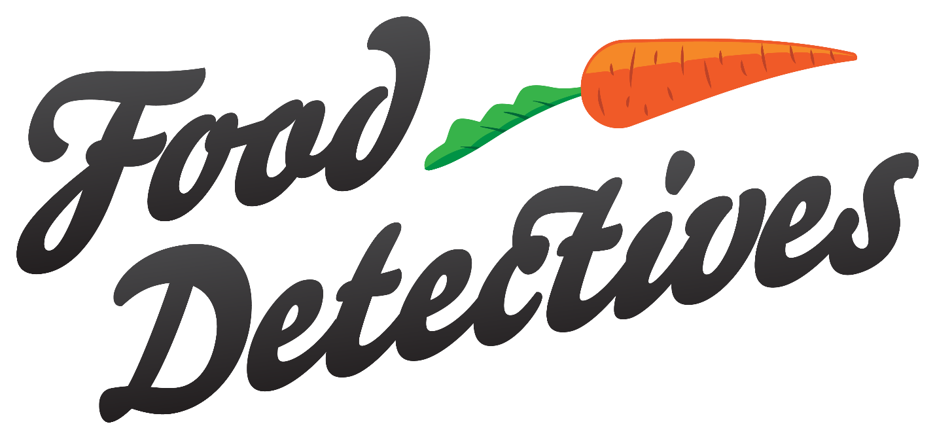

Tutorial

Senior Project

Contents

Download Visual Code Studio 4

Installation Guide: 5

1. Start VS-Code Installation Process: 5

2. Accept the License Agreement 5

3. Choose Installation Directory: 6

4. Choose Start Menu Folder: 6

5. Choose Additional Options: 7

6. Review selected options: 7

7. Launch the Visual Studio Code: 8

8. Editor Screen Opens: 8

Install Node.js 9

Select which Operating system you have. 9

1. Setup 9

2. License Agreement 10

3. Destination folder 10

4. Custom Setup 11

5. Tools for Native Modules 11

6. Ready to install Node.js 12

7. Finish 12

How to open Food Detectives Project. 13

1. Open Visual Code Studio 13

2. Create folder on Desktop for the project, then click Open folder. 13

3. Select Folder: ex Test_Folder 14

4. Inside of the folder right click and click on Open Terminal 14

5. Open Terminal on the bottom 15

6. Insert line here. 15

7. Install modules 16

8. Deploy 16

9. Browser 17

# Download Visual Code Studio

1. Go to <https://code.visualstudio.com/>
2. Press Download Windows/MAC.
3. Install.

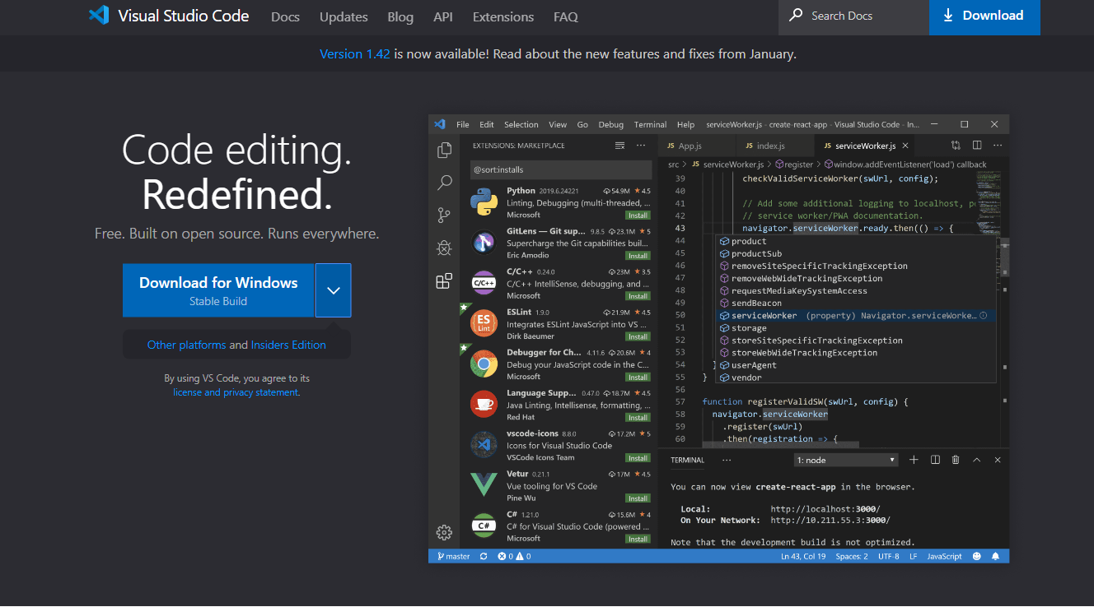

# Installation Guide:

### Start VS-Code Installation Process:

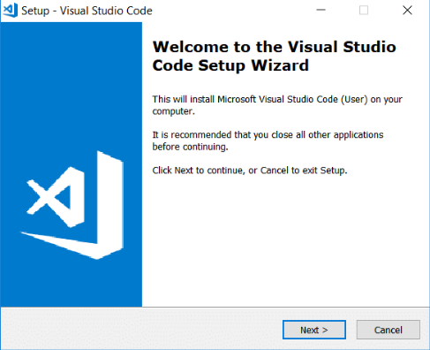

1. Accept the License Agreement:

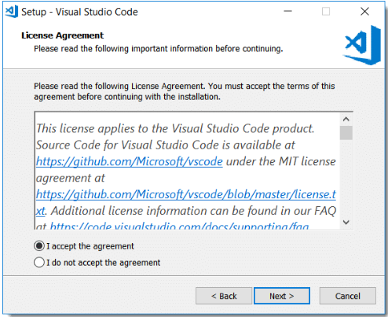

### Choose Installation Directory:

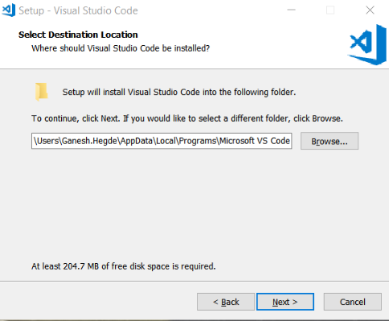

### Choose Start Menu Folder:

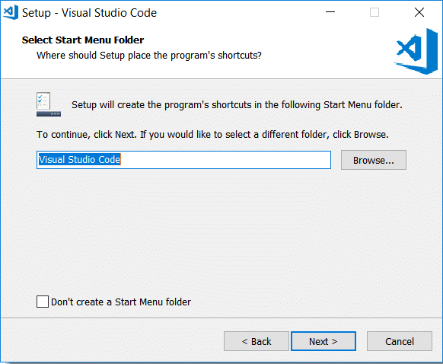

### Choose Additional Options:

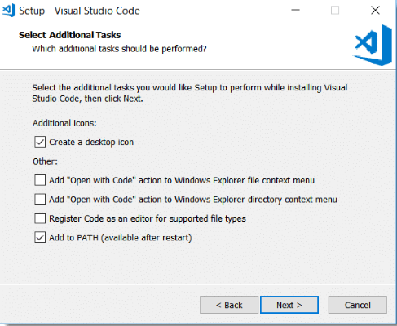

### Review selected options:

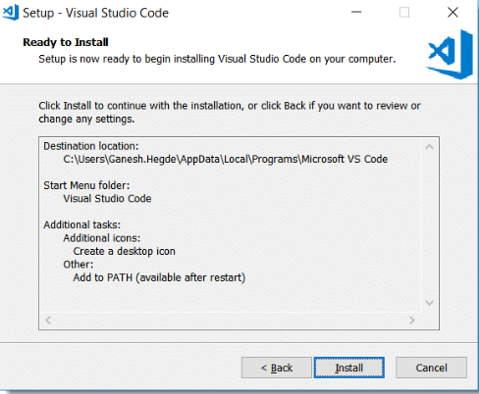

### Launch the Visual Studio Code:

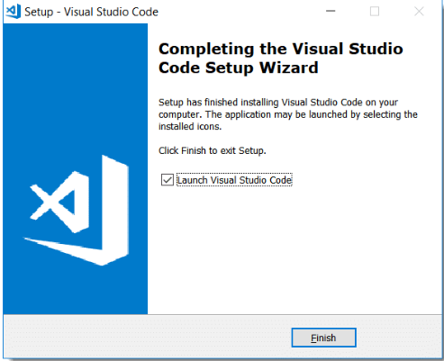

### Editor Screen Opens:

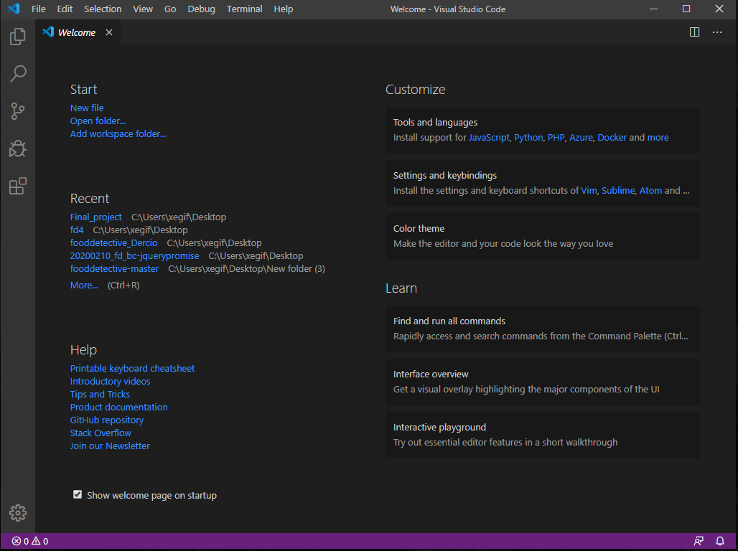

## Install Node.js

<https://nodejs.org/en/download/>

### Select which Operating system you have.

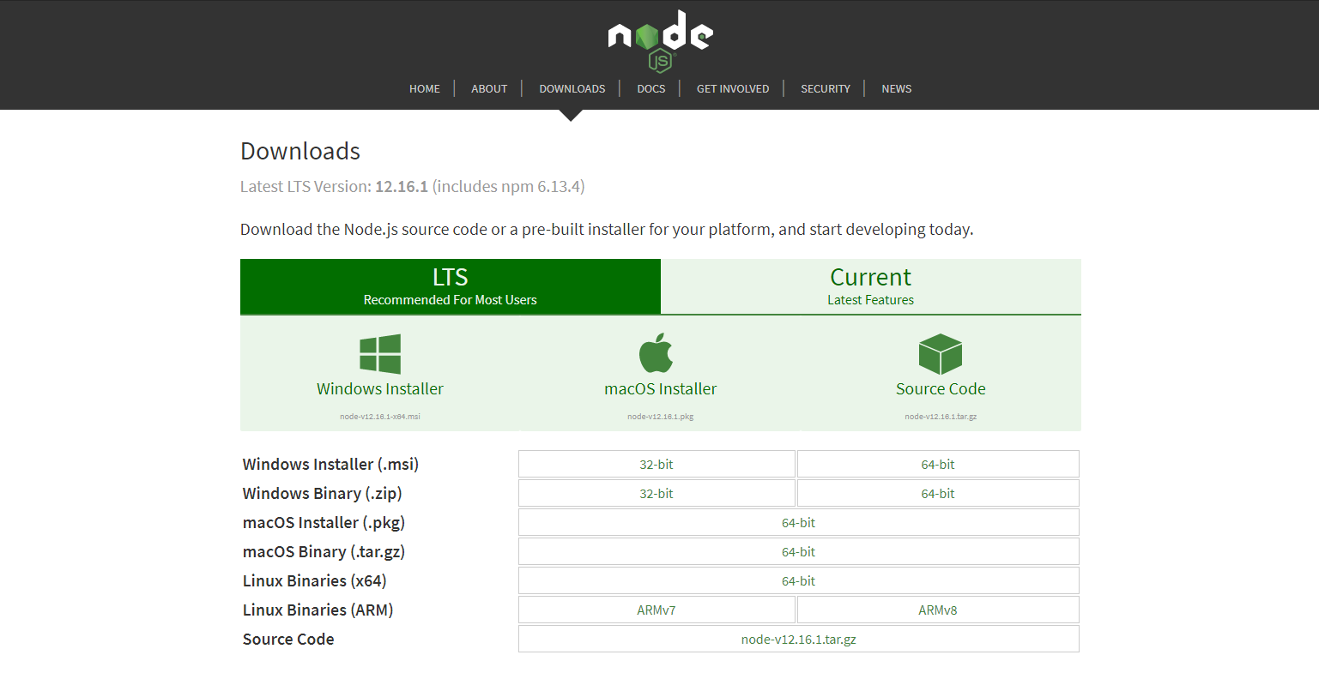

### Setup

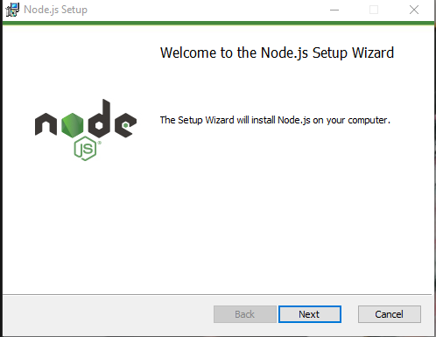

### License Agreement

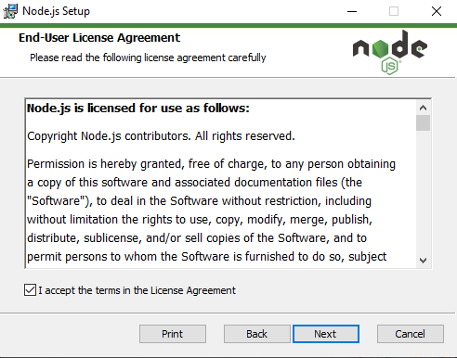

### Destination folder

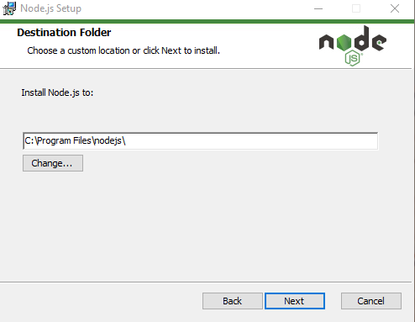

### Custom Setup

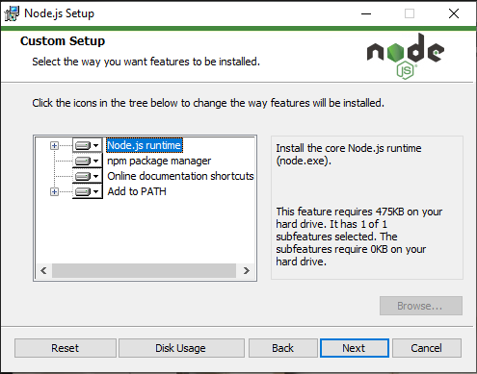

### Tools for Native Modules

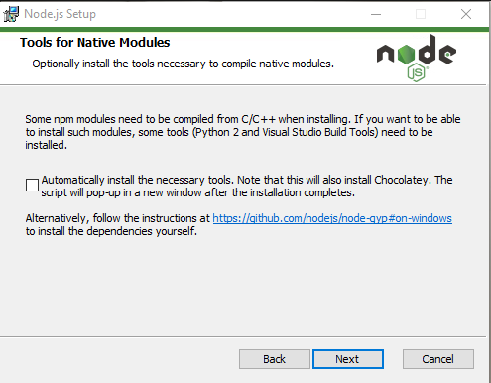

### Ready to install Node.js

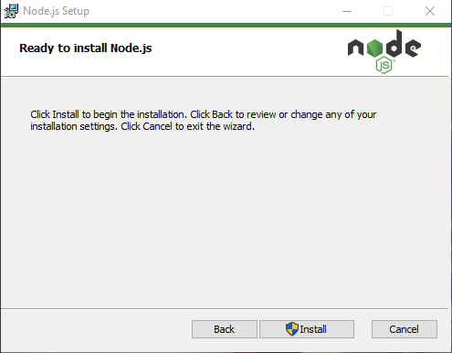

### Finish

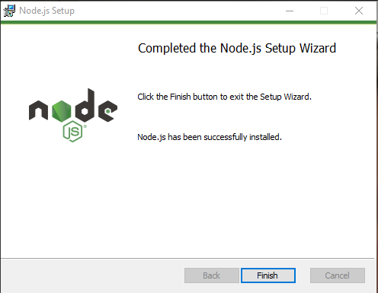

# How to open Food Detectives Project.

### Open Visual Code Studio

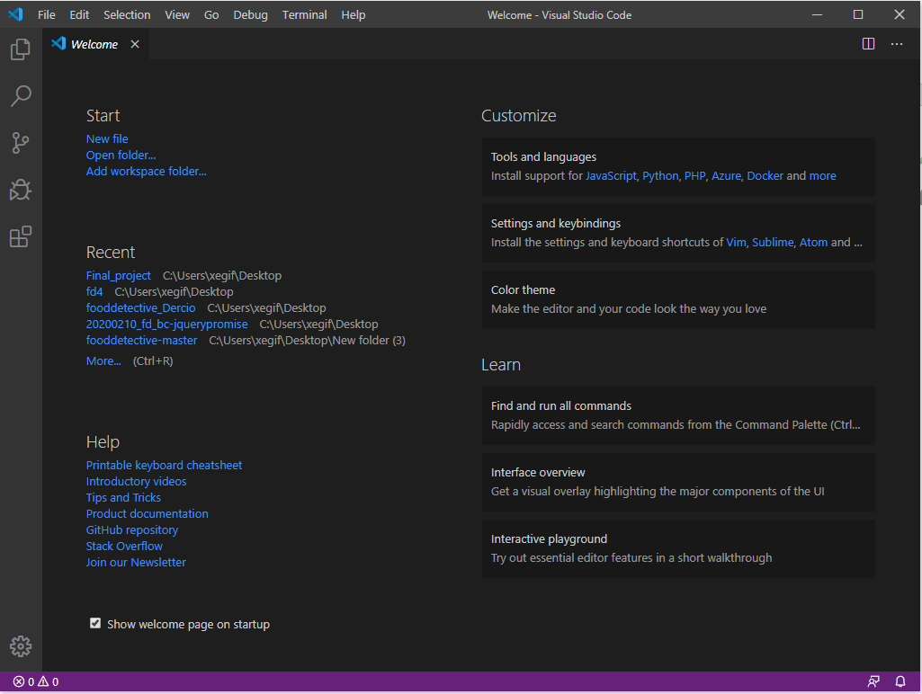

### Create folder on Desktop for the project, then click Open folder.

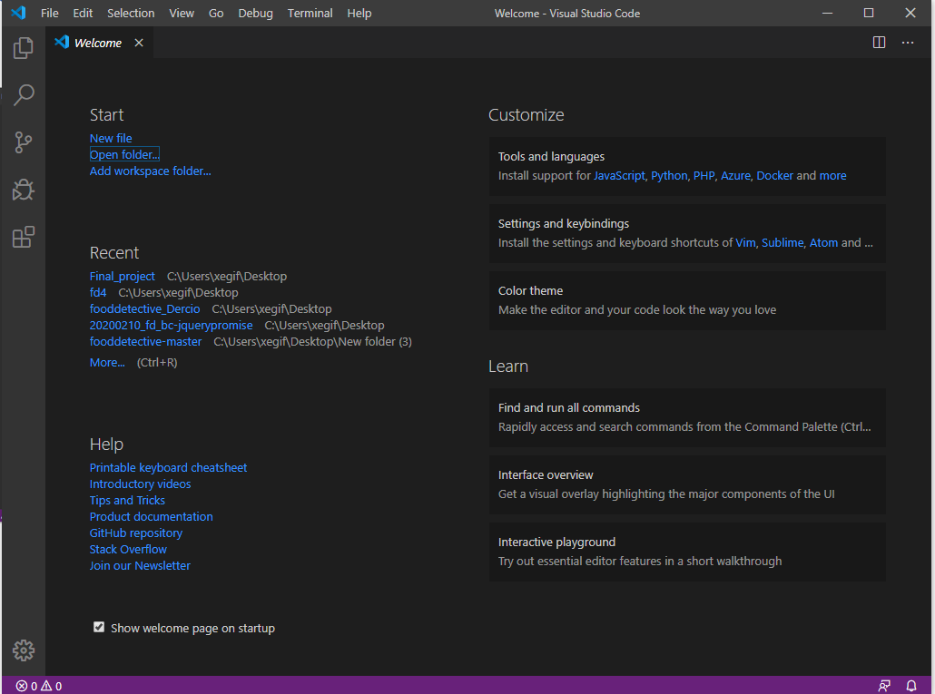

### Select Folder: ex Test_Folder

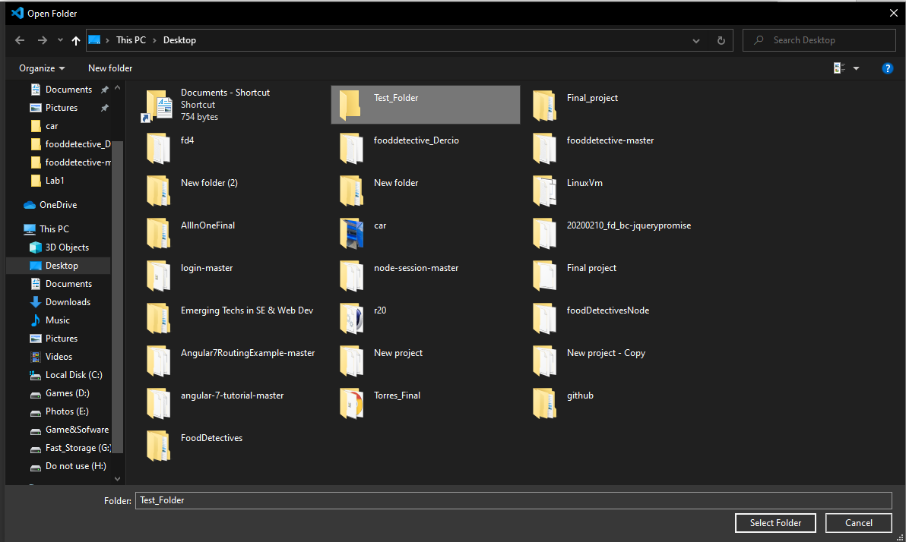

### Inside of the folder right click and click on Open Terminal

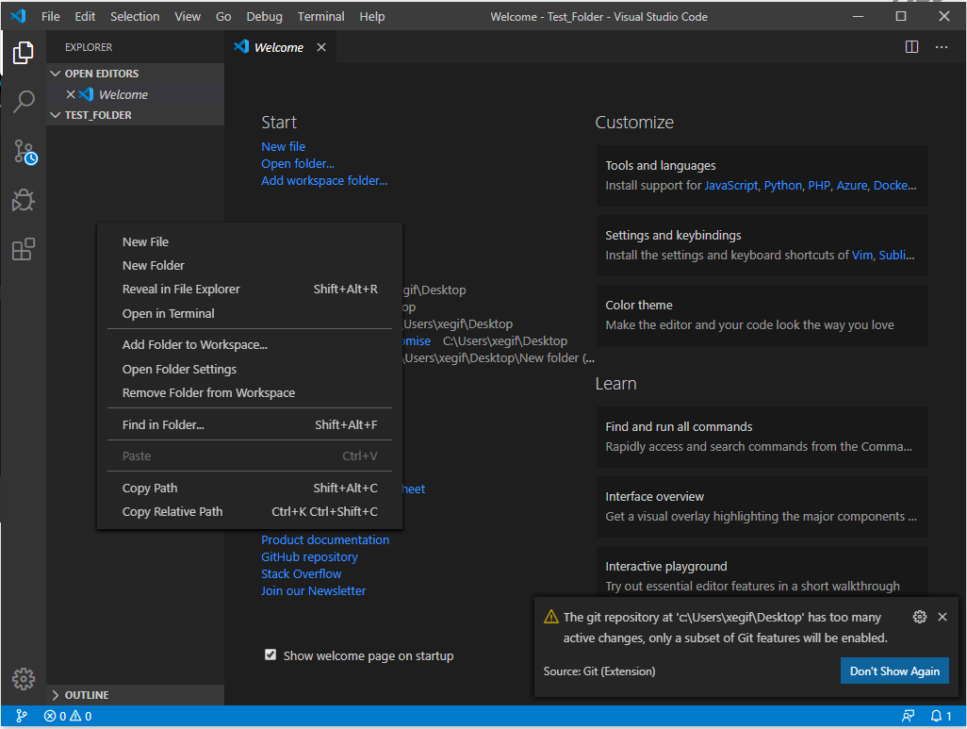

### Open Terminal on the bottom

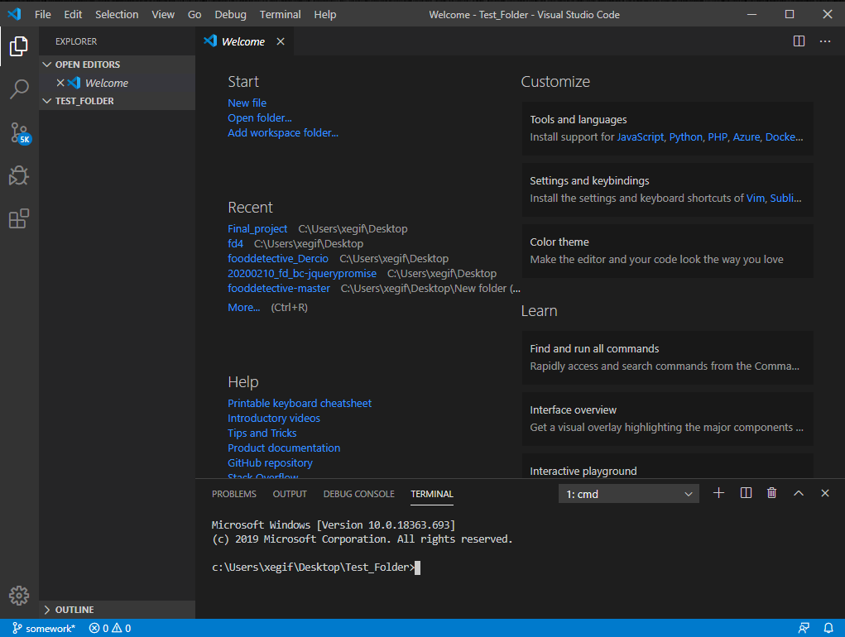

*Make sure you are inside of the folder.

### Insert line here.

git clone https://github.com/BColantonio/fooddetective.git

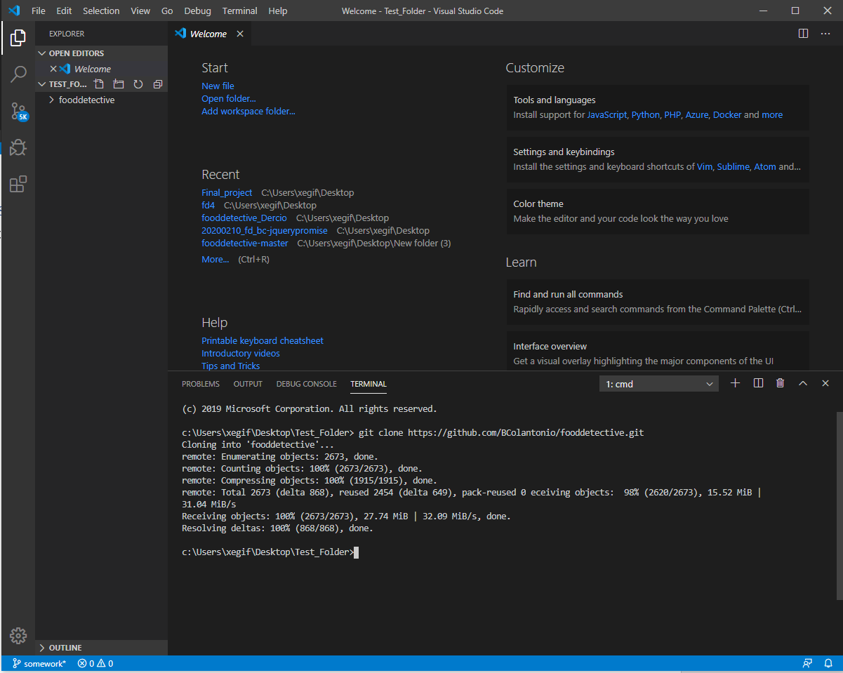

### Install modules

npm install

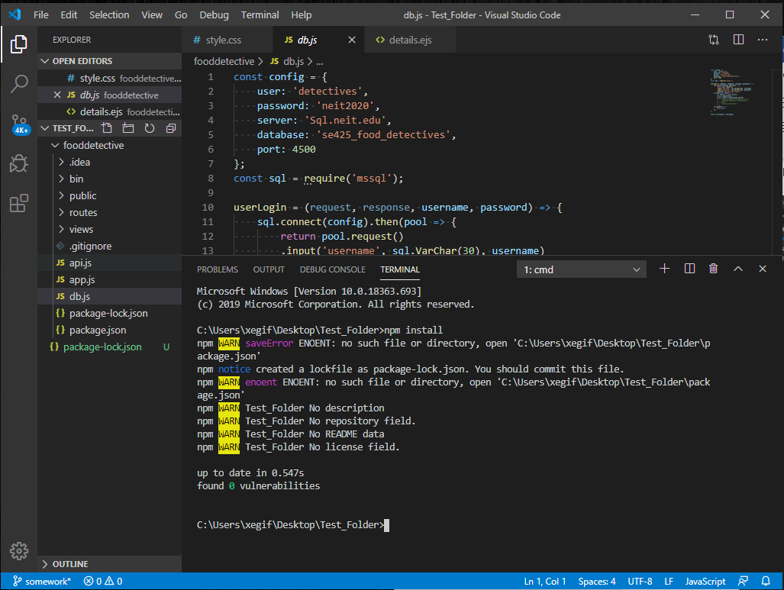

### Deploy

Nodemon fooddetectives

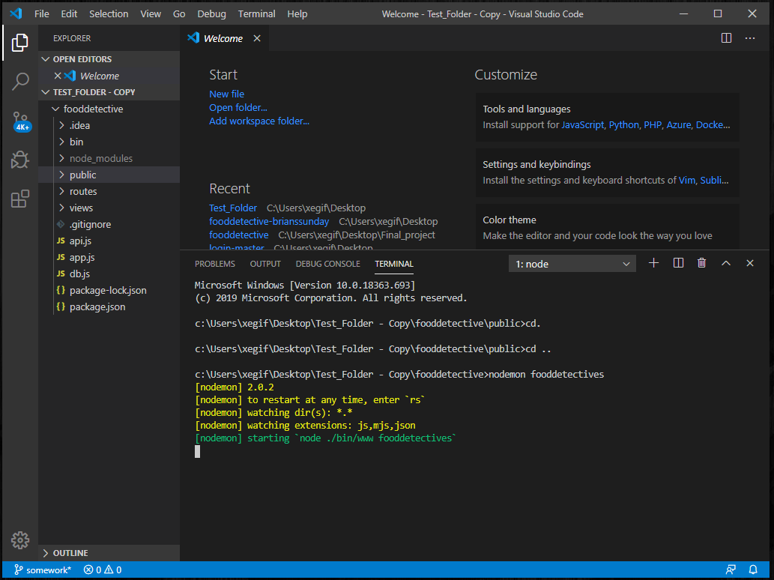

### Browser

<http://localhost:5000/>

